**PROJECT DOCUMENTATION**

* TITLE:

The name of the application is TO DO APPTM

* PROJECT OVERVIEW
* Description:

The APP is to help set tasks, create bookings, create personal notes and streamline collaboration between teams and project managers.

* Purpose:

The purpose is to assist lone developers and teams streamline their tasking process.

* Objectives:

1. It aims to help the user organise his or her tasks in an orderly manner.
2. It helps to create bookings of events which the user wants to attend and remind the user before the set time.
3. It helps the project manager to be able to set tasks right from his desk and assign the tasks and in turn the Assignee in turn gets notified that he has a particular task.
4. To help manage the user’s personal notes.

* Members of the Team involved:

1. Adedeji Oluwatobi – The Back-end Engineer.
2. Ojo Tolulope – The Front-end developer.

* PROJECT SCOPE:
* Boundaries and Extent:

The Project does not go beyond task management, bookings organiser and personal notes taker.

* PROJECT FEATURES:
* PROJECT TAB:

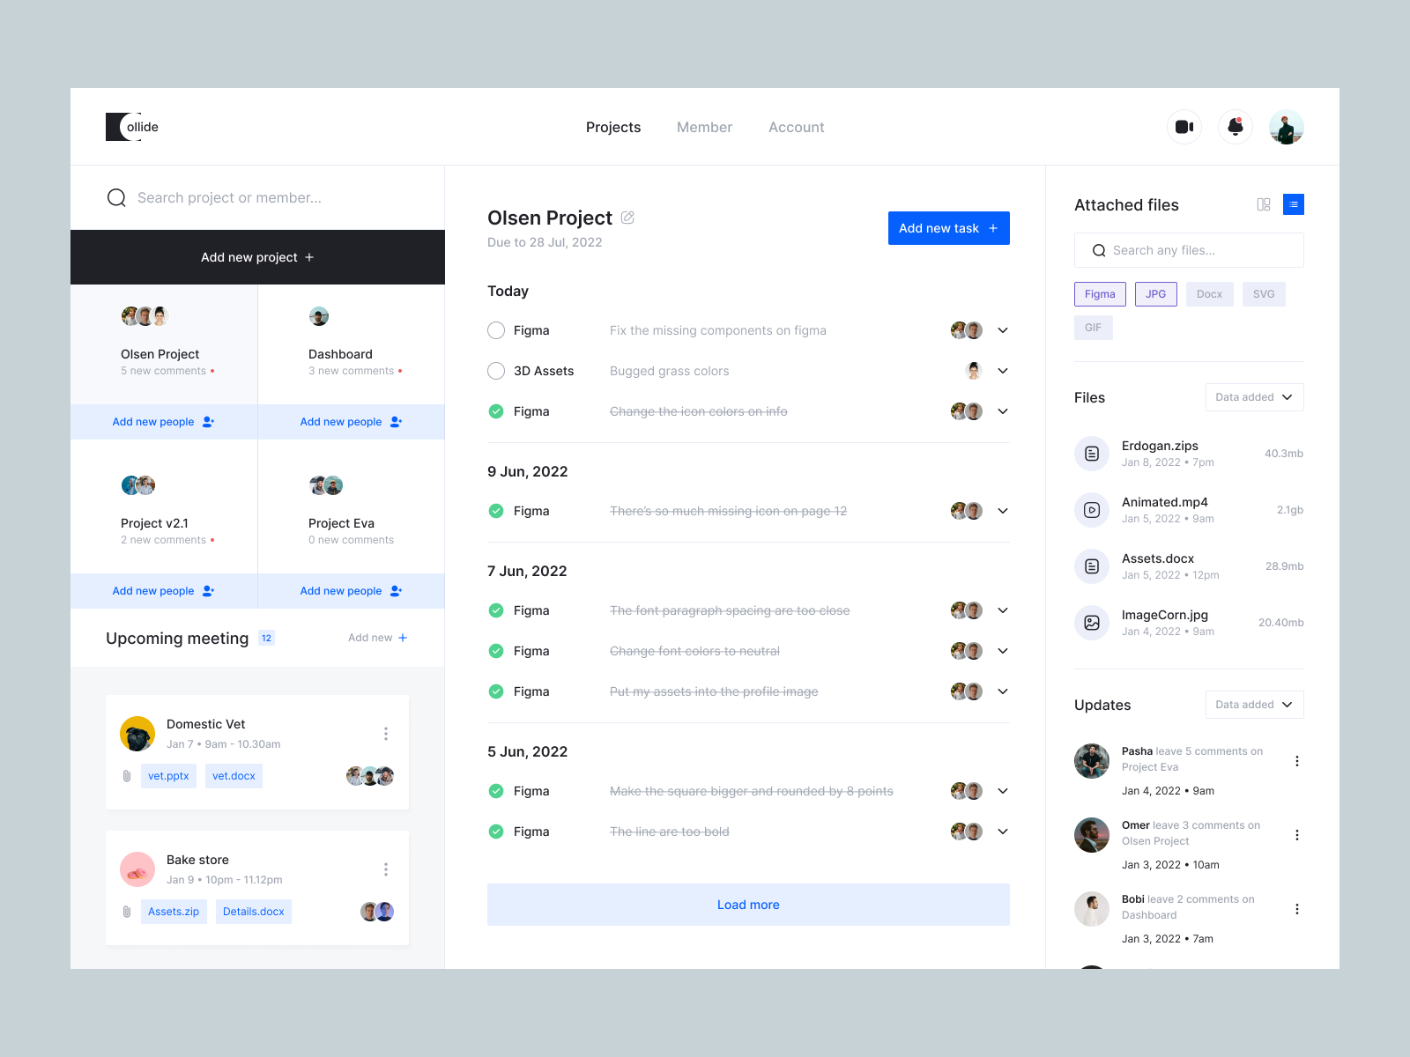

Using this wireframe, we shall exclude the video chat functionality in this project.Please ignore the **MEMBER** and **ACCOUNT** section of the NAVBAR. Instead of this, what will be there is **BOOKINGS** and **PERSONAL NOTES**

In the **NAVBAR** there shall be the logo at the top left while at the top right



there shall be the notifications button where one can toggle it on to receive notifications or off not to receive notifications. There shall also be a profile picture at the top right corner where one can update ones profile pic, email and adjust general settings.

In the **SIDE-MENU**

1. There is a search button where one can search for existing projects or search for a particular member.



1. Below the search functionality- there is a button that is used to **CREATE A PROJECT**. when clicked a form will show forth which has an input that also collects the deadline of the project. It also has a radio button to decide if it is a SELF PROJECT or TEAM PROJECT.

It also has an input that collects the description of the project.

1. Below the button- there is a pane that contains the **CREATED PROJECTS , **here we’ll see the project name (and the profile picture of existing team members on the project if it is a project that is for team). In the admin view(Admin of a particular project) – A **ADD NEW PEOPLE** button shows up underneath the project name if the user is an admin of the project- if the admin adds an existing user of the **TO-DO APPLICATION** to the project, the particular project will show up at the added person’s list of projects and instead of the add new people what will be there is **CLICK TO JOIN**. If one clicks on the particular project it gets displayed in the middle section that contains the tasks which has been completed and the ones that have not been completed. At the top right corner of the middle section exists a button which when clicked displays the CREATE NEW TASK box where one can create the task. This CREATE NEW TASK BOX collects the Title of the task, the description of the task, the person(s) for the task(if there is no other person in the project other than the user then it will default to self), the deadline for the task(if the deadline field is not filled it will only remain in the date section it was created. Assuming a user(or the admin in the case where it is being used by teams) creates a task on the 16th of July, 2023 and did not fill the deadline for the date section then the task will be created under the date section of 16th of July, 2023 and will not push itself even if the task was not completed.).
2. Below here the Admin for the particular project can set the meeting time and all users will be notified and the the meeting will get booked in their bookings tab and they will be notified if there is a conflict in the bookings tab. 

**In The Main UI(the middle section):**



1. At the top of the main UI, there is the heading section that displays the **PROJECT NAME**.  Next to the Project name is an edit icon whereby if one click on it an EDIT BOX pops out where one could edit the name of the project, push the deadline for the project, change the description of the project, and the admin for the particular project could remove a person from the project or delete a project. It also has a delete button, if the delete button is clicked a confirmation box shows up asking if the user wants to take the desired action. If yes then the project gets deleted and will be removed from the accounts of all users.
2. Beneath it is the deadline for the project. 
3. At the right hand section is a button to **CREATE A NEW TASK** when clicked a CREATE NEW TASK BOX pops out where the user can add the Title of the task, the description of the task, the person(s) for the task(if there is no other person in the project other than the user then it will default to self), the deadline for the task(if the deadline has not been reached the task will keep pushing itself and will stop when the deadline has been reached or the task has been completed. NOTE: if the deadline has been reached and the task has not been completed it will not push itself).
4. The **DATED SECTION** shows the task that has been created. The DATED SECTION will always show the date which the task was created. Under the DATED SECTION is the Individual Task which contains the Title of the task, The description of the task if there is any,before the profile picture is a little round green light that will show if the assignee has added a file and an optional text and the task has not been marked as completed(once marked as completed the green light will cease to show), the profile picture of the assignee(the persons for the task)if the user is the only one on the project then no profile picture will be displayed. Next to it is a **SHOW MORE ICON** when this is clicked the Individual task section gets extended, if it is the admin(in the usecase of teams) the admin will be able to extend the deadline and will also be able to mark the project as completed once the user has submitted the file and any optional follow come text. If it is the team member(assignee) that clicks the SHOW MORE ICON, he/she will be able to send a file and an optional follow come text to prove that the task was completed. If it is not an assignee but still a team member, he or she will see a text showing the status of the task. If it is a single user what he/she will be able to do is either extend the deadline or mark the task as completed. **NOTE:** If in the team usecase, only the Admin gets to mark the task as completed, no team member other than the admin can mark it as completed.

**IN THE FILE SECTION(**The right hand section**): **

This is the section that shows up only for teams, it will not show up if the project is marked as a SELF project. Under this section, what shows up are the files that has been shared.

* **THE BOOKINGS TAB**

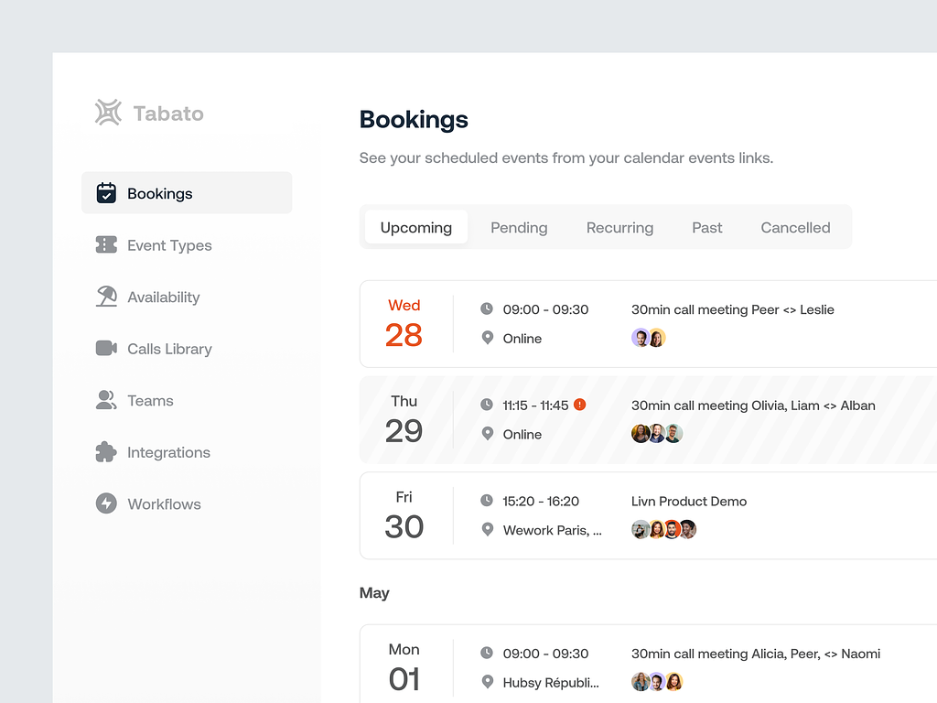

**This is the Bookings tab.** The wireframe above has no **NAVBAR,** but in this project, it will have the NAVBAR, There will not be a side menu like the one shown in the wire frame above.

**THE MAIN UI:**

It is going to have the main heading which will be **BOOKINGS** and it will also have a little text beneath.

**ADD NEW BOOKING BUTTON-** this is a button which when clicked displays a ADD NEW BOOKING BOX where one can enter the date, time,type of event, location, title and the participants of the meeting if the meeting was culled from the PROJECT TAB(If the booking of the event was created by the admin of a particular project in your project tab.).

Beneath the ADD NEW BOOKING, there will be a “secondary NAVBAR” that the user can use to navigate through **upcoming, recurring, past and cancelled events.**

Depending on what link is clicked, let’s say for the actual fact of explaining, the user clicks the UPCOMING events link. Then what will get displayed are the upcoming events.

* **THE PERSONAL NOTES TAB**

**(THE PERSONAL NOTES WIREFRAME IS AVAILABLE AS A SHORT VIDEO.)**

This is a tab that contains the personal notes of the user it can not be shared with anybody. It remains personal to the user unless shared by the user.



A **NAVBAR** that carries that has the logo and shows which particular tab the user is on.

A **SEARCH FUNCTIONALITY** at the top such that when clicked one will be able to use keywords to search for personal notes.

A **SIDEBAR-** this contains only a add button that when clicked adds a new note paper to the UI where the user can further add text.

A **MAIN UI-** this is where the created note paper gets displayed.

* **PROJECT TECHNOLOGIES**

FRONT END-

1. HTML
2. CSS
3. VANILLA JAVASCRIPT

BACKEND-

(NOT YET CONCLUDED AS AT THE TIME OF WRITING)

* **PROJECT TIMELINE:**

**FRONTEND TIMELINE:** 7 working days from the start excluding weekends.

**BACKEND TIMELINE:** (NOT YET CONCLUDED AS AT THE TIME OF WRITING.)

**CRITICAL DATES(**Dates that could impact the progress of the project**):**

* Weekends
* **TARGET AUDIENCE:**

As a tool meant to improve collaboration the target audience in particular ranges from teams and lone user which could comprise of Frontend developers, Backend developers, Project manager, UI/UX designers, Web security practisioners, Programmers, Digital artists, Video editors, Video Animators, Data Scientist, Graphics designers….e.t.c.

**NEEDS OF THE TARGET AUDIENCE:**

1. A quick and easy to use collaboration tool.
2. Secure environment to manage task.
3. High level of security.

* **CONCLUSION:**

By the end of this project, it is expected that the needs of the Target audience is met and this includes prioritizing Security of the Application and providing a user friendly collaborating tool.

**SPECIAL THANKS AND PRAYERS:**

Our SPECIAL THANKS goes to the Creator and giver of Life for enabling us to do more and who will help us see the completion of the project which will benefit the entire human race.

We also do appreciate **ADEDEJI OLUWATOBI** for volunteering to fill the role of the Backend developer.